Depth Camera.

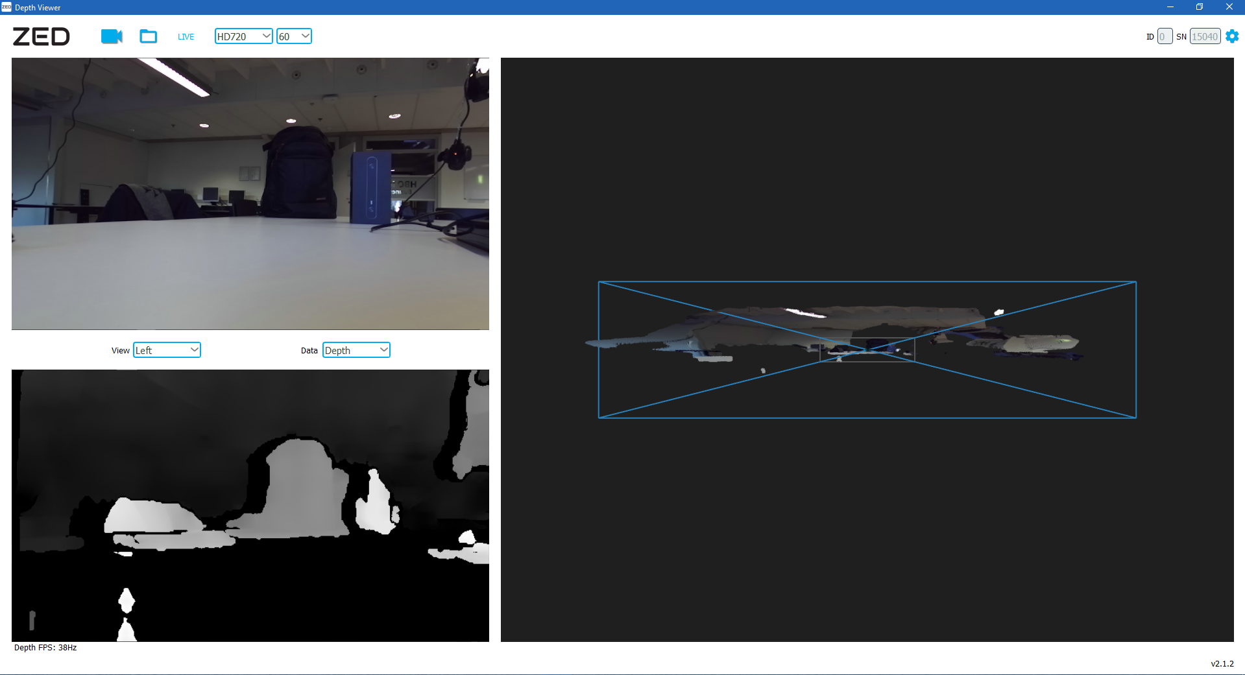

ZED Explorer

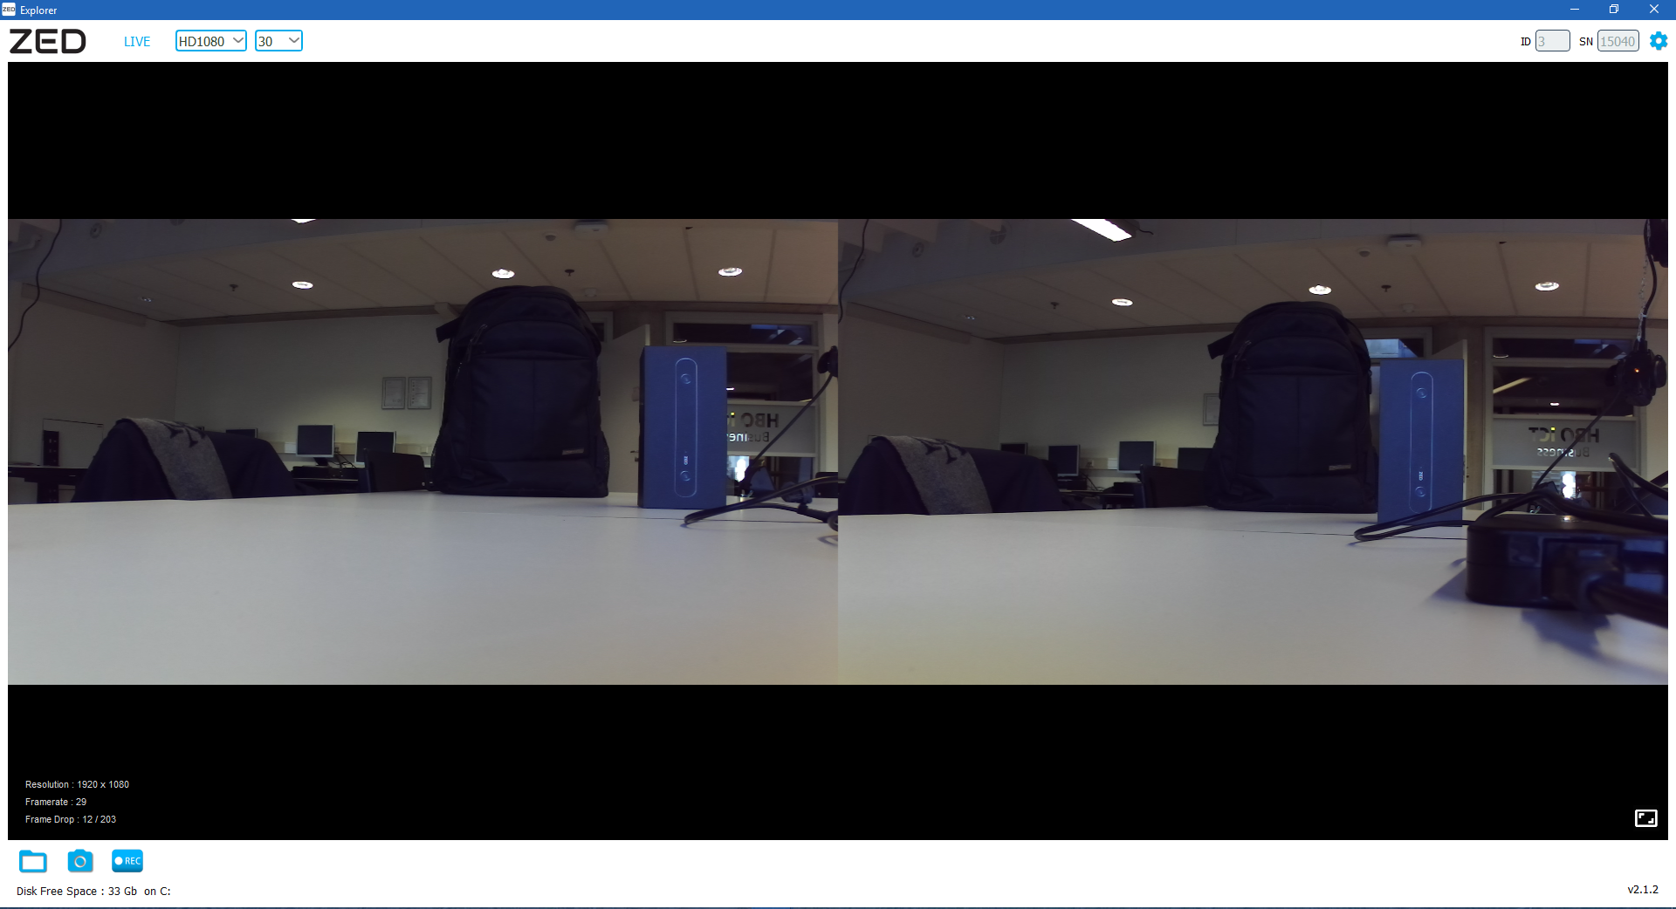

CUDA versie: v8.0 Feb 2017 (zonder patch)

<https://developer.nvidia.com/cuda-80-ga2-download-archive>

GPU: nvidia 840m (376.51)

ZED_SDK: 2.1.2

(<https://www.stereolabs.com/developers/release/2.1/#sdkdownloads_anchor>)